Golden Castle Riding Stables.

Proprietor: F. J. Griffiths

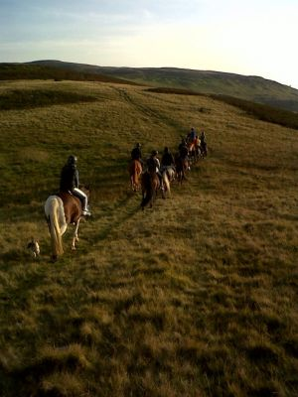

Health and Safety Manual

Contents

- Introduction
- Policy statement
- Induction
- Yard Rules
- Fire Precautions
- Manual Handling
- COSHH
- PPE
- First Aid Facilities
- General Risk Assessment

Appendix: A) Site plan
- Fire Procedure Notice
- Manual Handling
- COSHH data sheets
- Risk assessments
- BHS Risk Assessment Form
- BHS Employee Induction Checklist
- Declaration of Acceptance of Risk and Indemnity.
- Stable welcome message
- BHS fire risk assessment information
- The Objective of the Pony Club
- British Equestrian Federation Child Protection Policy and Duty of Care Guidelines.
- British Equestrian Federation Equal Opportunities and Equality Policy
- Daily Routine
- Isolation Procedures

1. Introduction

There is a widely held belief that health and safety is pedantic and restrictive. This is not true. The law requires that the owners of Golden Castle Riding Stables (hereafter known as ‘the stables’) do everything that is reasonable practicable to ensure the health, safety and well-being of anyone affected by their activities.

When deciding what is reasonable practicable the stables are permitted to balance the cost and inconvenience of potential control measures against the benefits that would result.

This document has been written to ensure that persons using the stables, members of the public and staff alike are aware of the health and safety responsibilities they have to themselves and to one another.

-----ooooo0ooooo-----

2. Health & Safety Policy statement

Golden Castle Riding Stables (hereafter known as ‘the stables’) exists to provide equine recreation and training for people of all ages and gender.

As far as is reasonably practicable it is the objective of the stables to ensure the health, safety and well-being of everyone affected by its activities.

Toward this objective an induction will be undertaken, for anybody new to the stables, and will include:-

    - A tour of the site
    - Basic ‘do’s’ and ‘don’ts’
    - Instruction in fire prevention and evacuation
    - Instruction on equipment and its use (PPE)
    - First aid facilities and accident reporting
    - Basic manual handling (jump erection)

Adequate planning, monitoring and review of the implementation of the Health and Safety Policy will be carried out. In order to ensure that this general statement is achieved, the following will form the stables’ aims and objectives

- The stables will provide, where necessary, information, instruction and training to ensure competence with respect to health and safety.
- The stables will provide the necessary equipment to ensure health and safety.
- The stable staff will have specific responsibilities to take care of themselves and the people in their charge.
- A system will be in place to ensure that incidents relating to health and safety are fully investigated and appropriate action taken to avoid a re-occurrence.

Date: Proprietor:

-----ooooo0ooooo-----

3. New Student/Staff Induction

All new students/staff will be given an induction before commencing. The induction will include: -

- Site familiarisation
- Fire precautions
- First aid facilities
- Horse awareness (if necessary)

A copy of the BHS Employee Induction Checklist can be found in Appendix F.

4. Yard Rules

- No running
- No shouting
- No climbing on gates, fences or doors
- Look after equipment, if you get it out, put it away
- Mind your feet
- Wear your hat and boots at all times
- Wear suitable clothing, tie your hair back
- Keep all doors shut
- Open doors wide for horses and then shut them
- Do not give treats without permission
- No chewing gum
- No smoking

A copy of the stable welcome message with do’s and don’t’s is in appendix I.

5. Fire precautions

A plan of the site and location of fire fighting equipment can be found in appendix A. The general public are advised NOT to attempt to fight the fire, leave this to trained members of staff.

Any evacuation of horses must be made under the control of members of staff.

On detecting a fire or hearing the fire alarm follow the instructions in the evacuation procedure (appendix B). Evacuation procedure notices are on display around the site.

A copy of the BHS Fire Risk Assessment Information can be found in appendix J.

6. Manual Handling

Members of staff will often be involved in erecting fences for jumping. Sometimes students will also be involved, this is an integral part of the stables training programmes.

A commonsense approach must be adopted in this activity, staff and members of the public are advised not to overreach them selves, and always work within their own physical limits.

A general Manual handling guide can be found in appendix C.

7) Control of Substances Hazardous to Health
(COSHH)

All hazardous substances are safely stored and the data sheets can be found in appendix D.

8) Personal Protective Equipment (PPE)

It is vital that PPE appropriate to the task is worn at all times.
All PPE is regularly checked to ensure that it is fit for purpose.

All tack is cleaned and inspected regularly.

9) First Aid Facilities

The first aid box is kept in the stable office and is regularly inspected to ensure that it is fit for purpose.

Accidents must be reported in the accident book which is kept in the stable office.

10. Risk assessment

All activities that pose a risk to staff and members of the public are risk assessed using the BHS risk assessment format (Appendix F). Risk assessments are reviewed regularly or on a change in circumstances to ensure that they remain current and fit for purpose. The risk assessments listed below can be found in appendix E.

Appendix A

Site Plan

Appendix B

Golden Castle Riding Stables.

Fire Evacuation Procedure

In the event of a fire:
Raise the alarm (triangle hanging in the yard).
Phone the Fire Brigade.

On hearing the alarm:
All horses that can be safely moved should be taken to the
bottom field.
Shut as many gates and doors as possible.
Go straight to the fire assembly point which is
located at the far corner of the outdoor school.

DO NOT stop to collect personal belongings.
DO NOT risk your life trying to fight any fire, leave this to
the trained staff.
DO NOT re-enter the building that is on fire.

A roll call will be taken by a member of staff at the
assembly point.

Do not leave the assembly point until instructed to by the
Fire brigade Officer.

Appendix C

The chart below is only a guide as to what the average male/female adult can lift safely.
It must, therefore, be reduced proportionately for children or less able people.

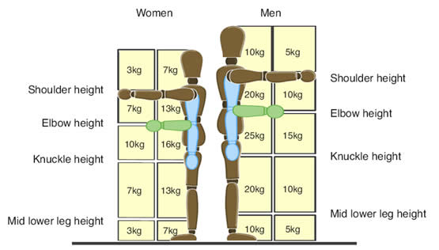

Appendix D

COSHH Data Sheets

Appendix E

Risk Assessments

- Changing rugs
- Cleaning Tack
- Feeding and watering
- Grooming
- Leading during lessons
- Mucking out
- Sweeping the yard
- Tacking up
- Turning out and catching horses
- Tying up horses
- Washing off horses
- Working in the school or barn
- Competitions
- Rides
- Loading Horsebox and Trailer

Appendix F

BHS Risk Assessment Form

Appendix G

BHS Employee Induction Checklist

Appendix H

Declaration of Acceptance of Risk and Indemnity

Appendix I

Stable Welcome Message

Appendix J

BHS Fire Risk Assessment Information

Appendix K

The Objectives of the Pony Club

Appendix L

British Equestrian Federation
Child Protection Policy & Duty of Care Guidelines

Appendix M

British Equestrian Federation
Equal Opportunities and Equality Policy

Appendix N

Daily Routine

Appendix O

Isolation Procedures

